Level 1:

Software Engineering Assignment

Module: 1

SE Overview of IT Industry

1. **What is software? What is software engineering?**

**Ans**. The software is a collection of integrated programs.

Software Engineering is an engineering branch related to the evolution of software product using well-defined scientific principles, techniques, and procedures.

1. **Explain types of software?**

**Ans**. **Application software:** The most common type of software is application software which is a computer software that performs a specific function for a user or in some cases for another application. An application can be self-contained, or it can be a group of programs that run the application for the user. Examples of modern applications include office suites, graphics software, databases and database management programs, web browsers, word processors, software development tools, image editors and communication platforms.

* **System software:** These software programs are designed to run a computer's application programs and hardware. System software coordinates the activities of the hardware and software. In addition, it controls the operations of the computer hardware and provides an environment or platform for all the other types of software to work in. The OS is the best example of system software; it manages all the other computer programs. Other examples of system software include the firmware, computer language translators and system utilities.

1. **What is SDLC? Explain each phase of SDLC?**

**Ans.** The software development lifecycle (SDLC) refers to the method which clearly defines the process for creating high quality software.

**Phases of SDLC**

1. Planning: It is a first step of the SDLC in this step all planning related to the project is placed and activities like resource allocation, risk management etc. comes under planning.
2. Analysis: In analysis whole project gets analysed in this step all details get gathered and documentation and validation process also come under this step.
3. Design: Create the architecture of the software this step includes system design and design of system components.
4. Implementation: Translate design into code in this step code get written to perform task.
5. Testing: In this step all code gets checked and all the things get checked so that there is no defect in the system or program.
6. Maintenance: Maintenance means that the software continues to work correctly. In maintenance step software get prevented from the bugs, virus etc.
7. **What is DFD? Create a DFD diagram on Flipkart**

**Ans.** A data flow diagram (DFD) means a graphical representation of the flow of data through an information system.

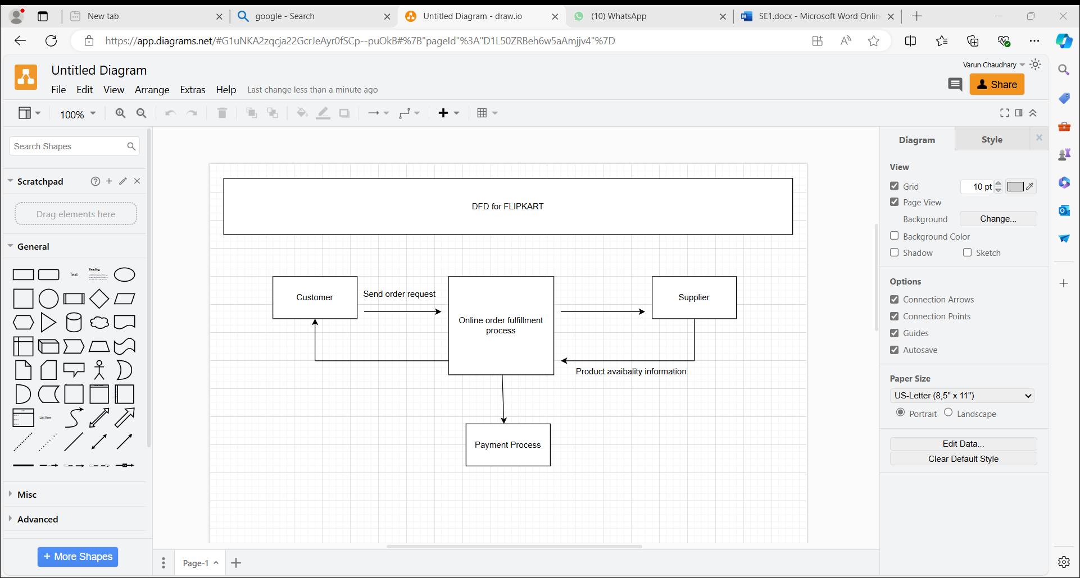

1. **What is Flowchart? Create a flowchart to make addition of two numbers**

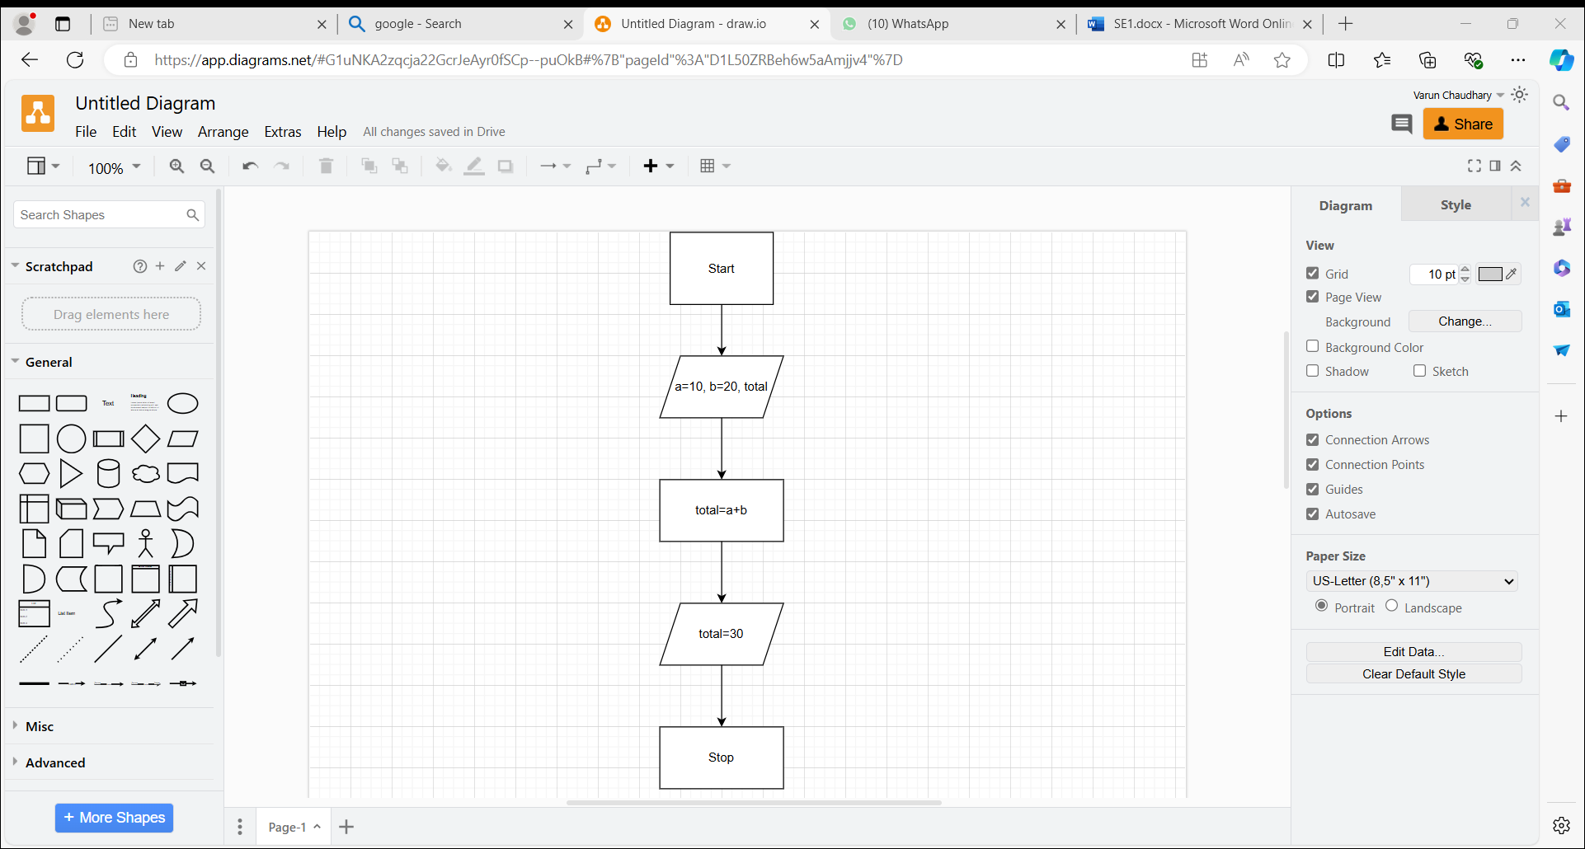**Ans.** Flowchart is a pictorial representation of algorithm. Because flowchart is made up of different shape it is easy to understand.

1. **What is use case Diagram? Create a use case on bill payment on Paytm?**

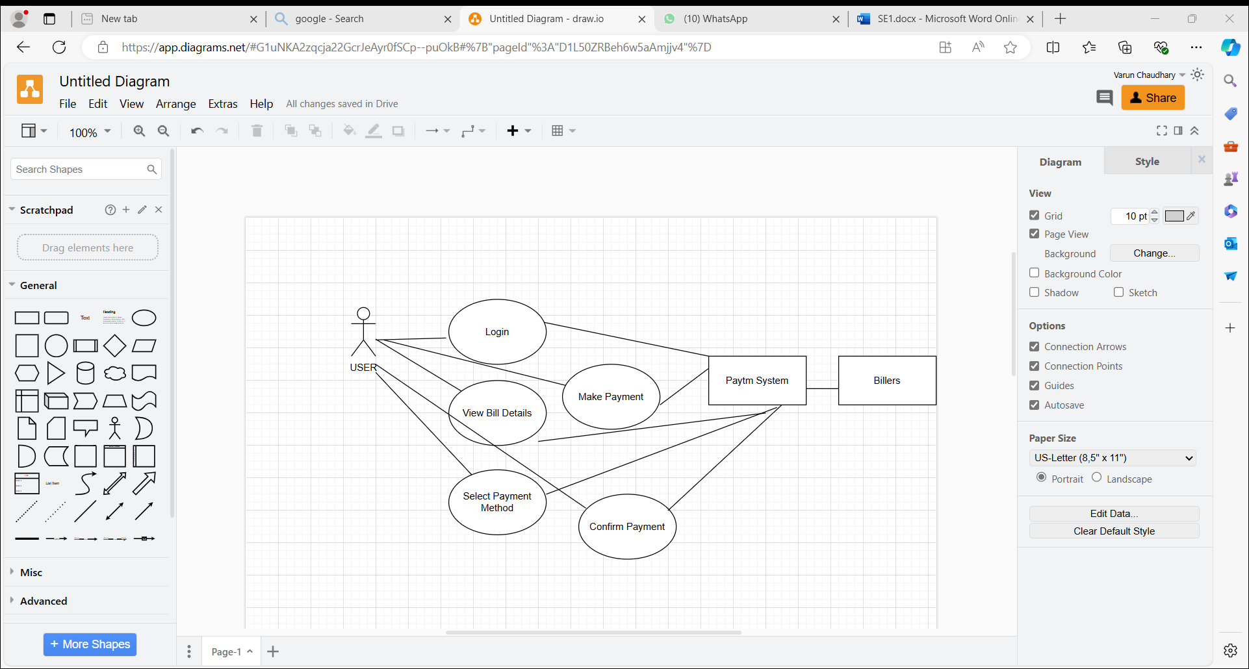**Ans.** Use-case diagrams describe the high-level functions and scope of a system. These diagrams identify the interactions between the system and the users.